Loch Lomond Fisheries Trust  Buchanan Castle Golf Course  Drymen  Glasgow  G63 0HY  Email: info@llft.org.uk  Phone: 07860395452 | 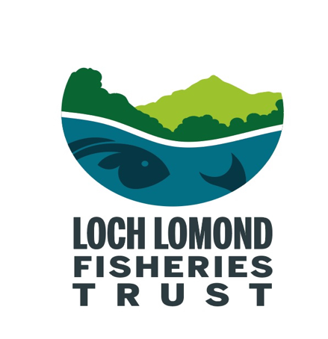
F.A.O Balloch Park Regeneration Group,

Riverwoods Investment Readiness Proposal – Glenfalloch Nature Restoration

Dear Alex

On behalf of the loch Lomond Fisheries Trust (LLFT) I would like to offer our full support to the Glenfalloch Nature Restoration application for Riverwoods investment readiness funding.

As you are aware the LLFT is an environmental charity that champions the conservation and restoration of the Loch Lomond catchment’s native fish populations, their habitats as well as the wider environment, both in-stream and the associated riparian zone. The River Falloch and it’s tributaries is home to many nationally and internationally important fish species namely Atlantic salmon which are listed on Schedule 3 of the Conservation (Natural Habitats, &c.) Regulations 1994; European eel which is regarded as critically endangered by the International Union for Conservation of Nature (IUCN) and is a priority species for a UK Biodiversity Action Plan (UKBAP); River lamprey are listed on Schedule 3 of the Conservation (Natural Habitats, &c.) Regulations 1994. The Falloch also has a run of sea trout and hence provides angling opportunities not only on the Falloch itself but in Loch Lomond and the River Leven.

Given the centrality of the River Falloch in your application, and the mounting pressures faced by these internationally important migratory species, the LLFT is extremely interested in, and supportive of, your proposals.

Not only does the Trust offer our full support we are also able to offer advice and guidance on proven riparian habitat improvement measures that would improve in-stream conditions for fish species across the Falloch catchment. Ultimately this will benefit fish populations and help protect migratory fish populations from anticipated climatic changes that could undermine ultimately this fragile ecosystem.

The LLFT also has experience of riparian planting and, if required, can also provide assistance in this important aspect of your project.

On behalf of the LLFT I wish you every success with this application.

Malcolm MacCormick
Operations Manager

